**Introduction to Graphs**

Graph 🡪 Non-linear data structure

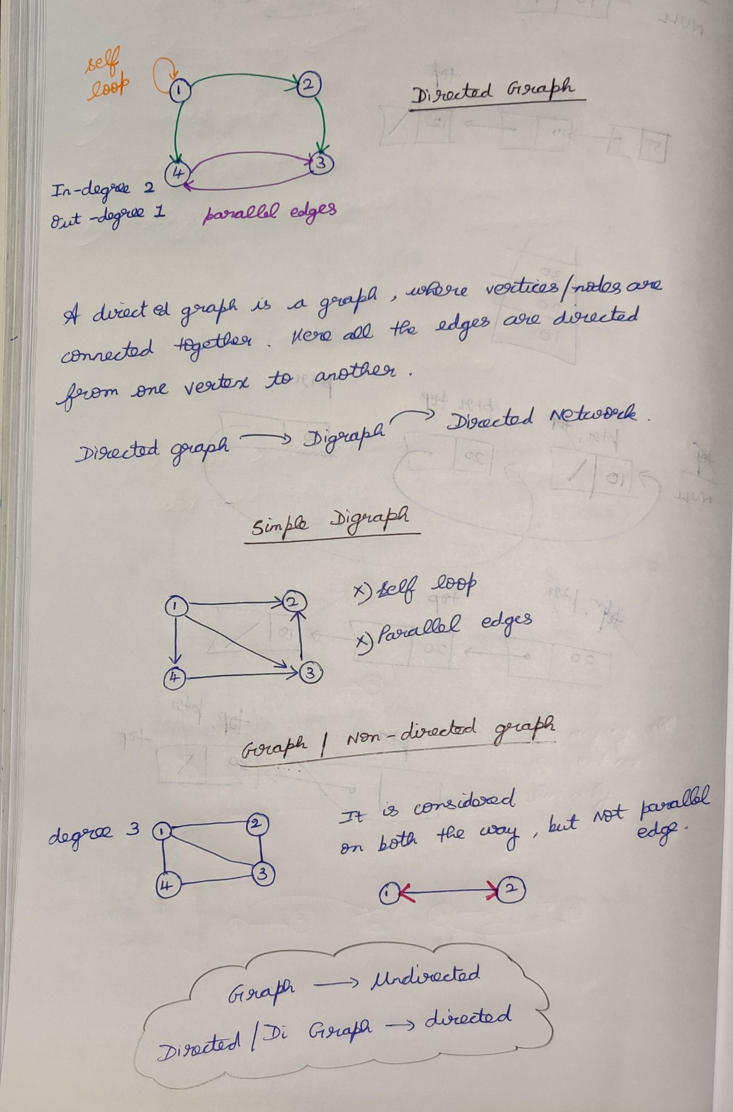

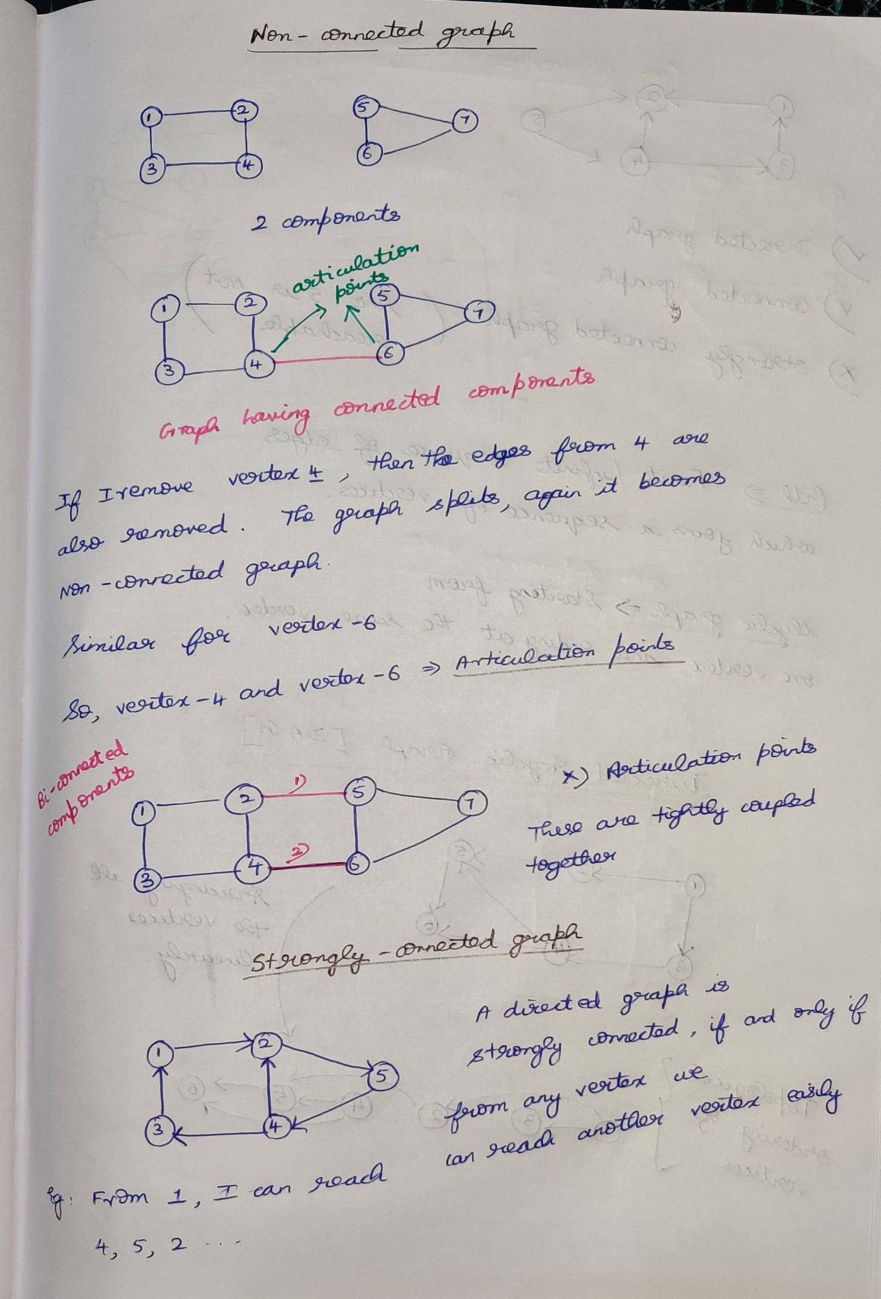

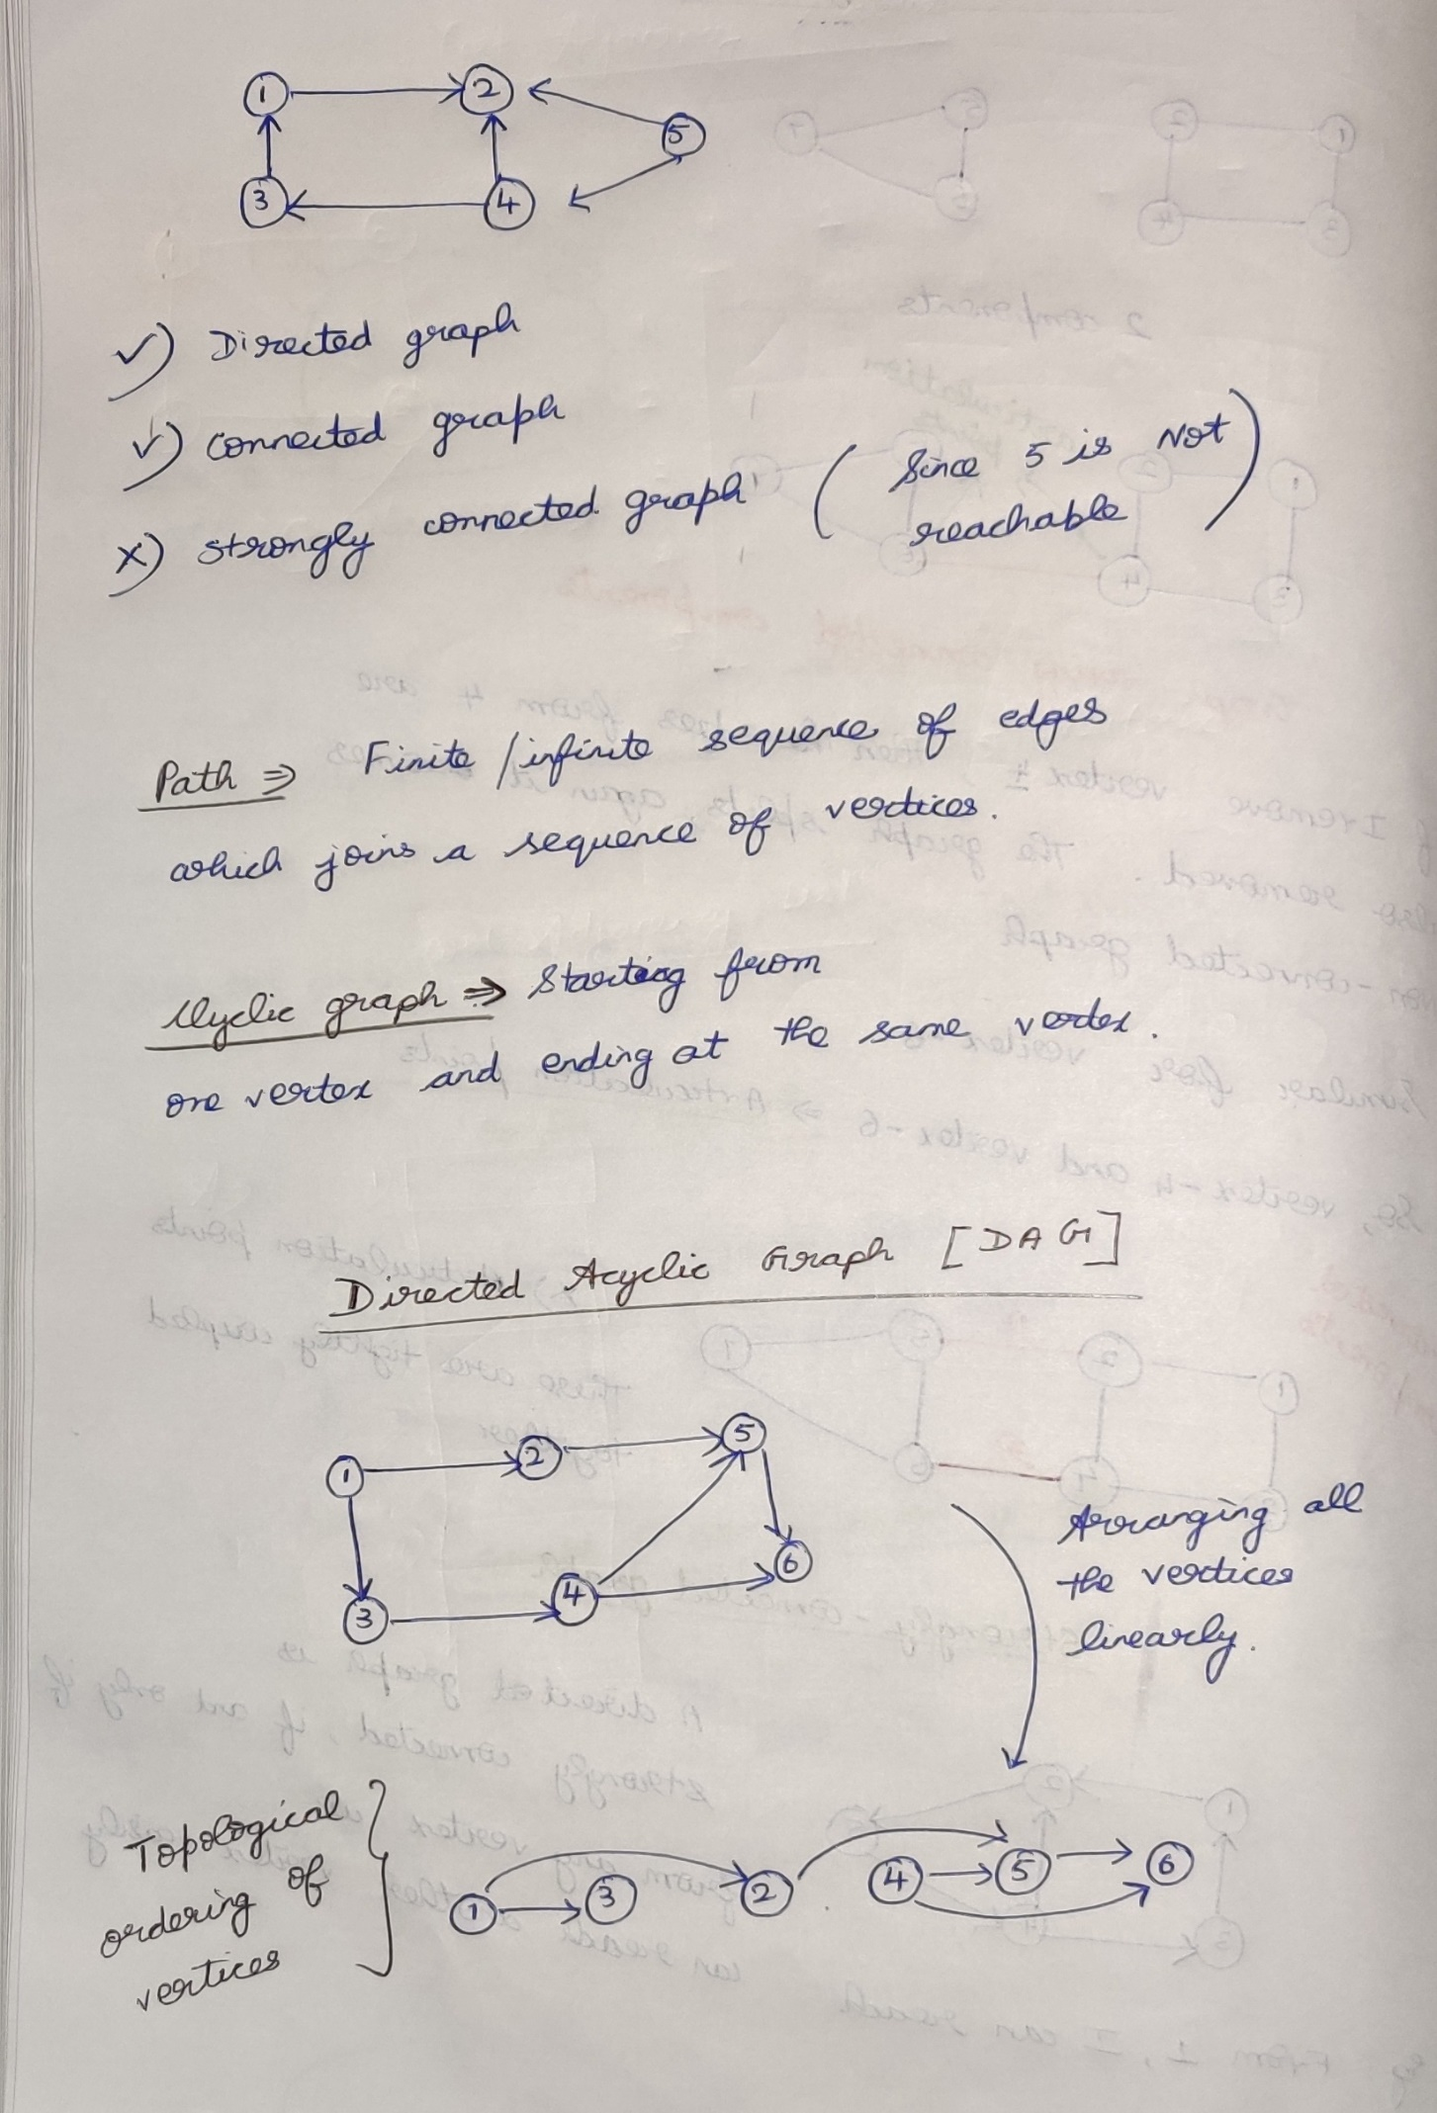

**Representation of Undirected Graph**

1. Adjacency Matrix
2. Adjacency List
3. Compact List

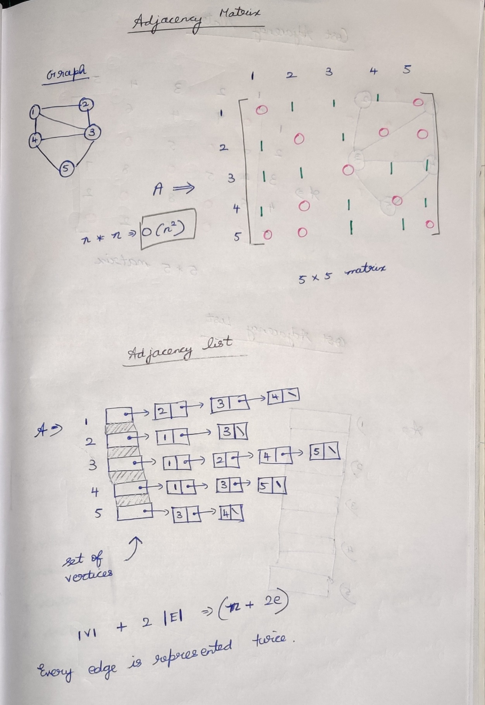

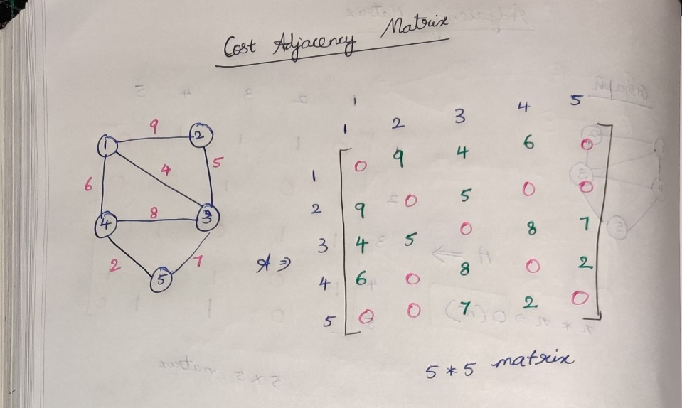

Cost Adjacency List

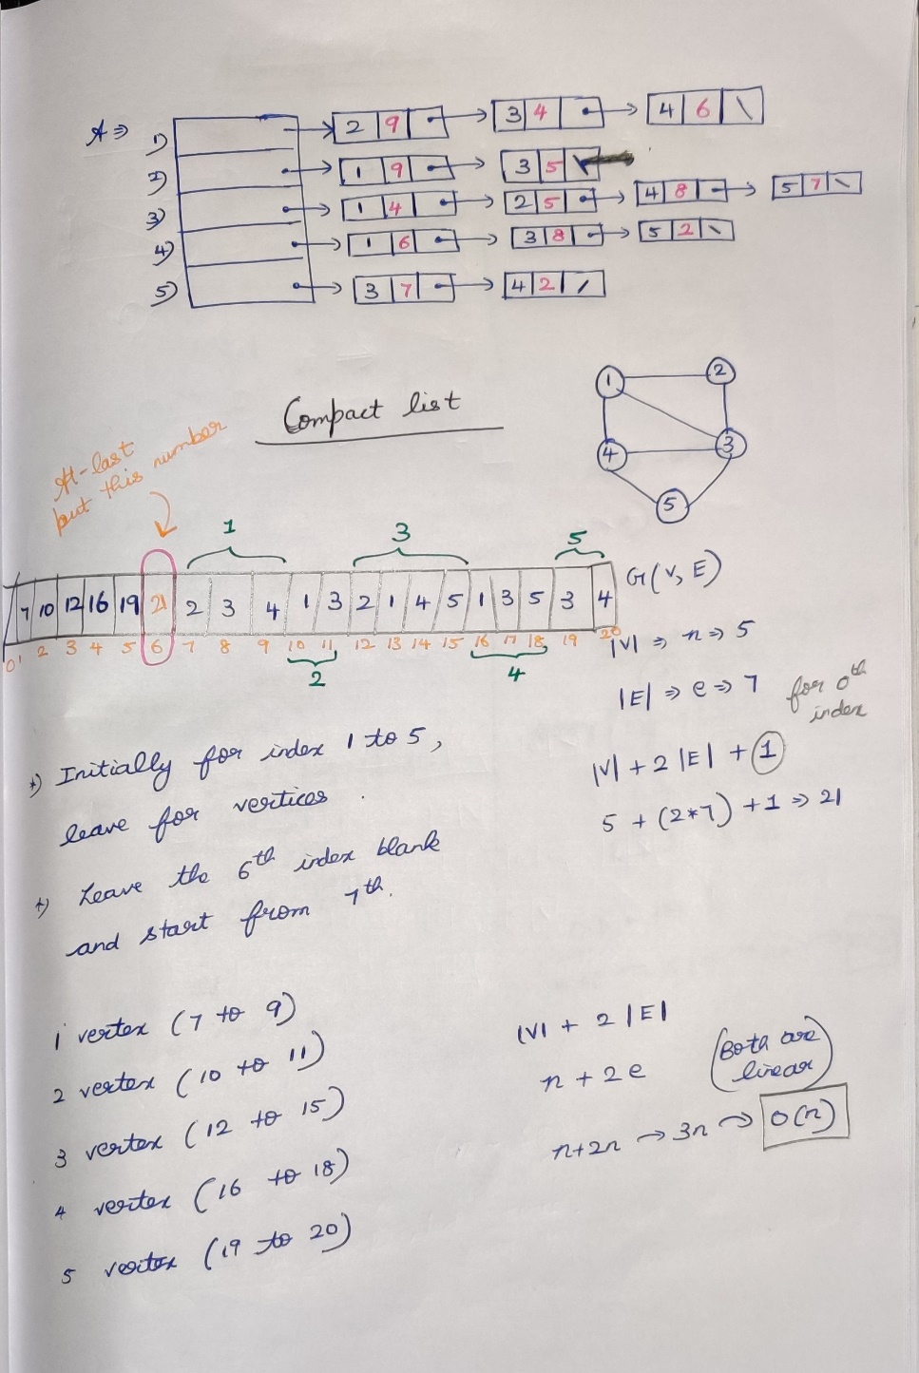

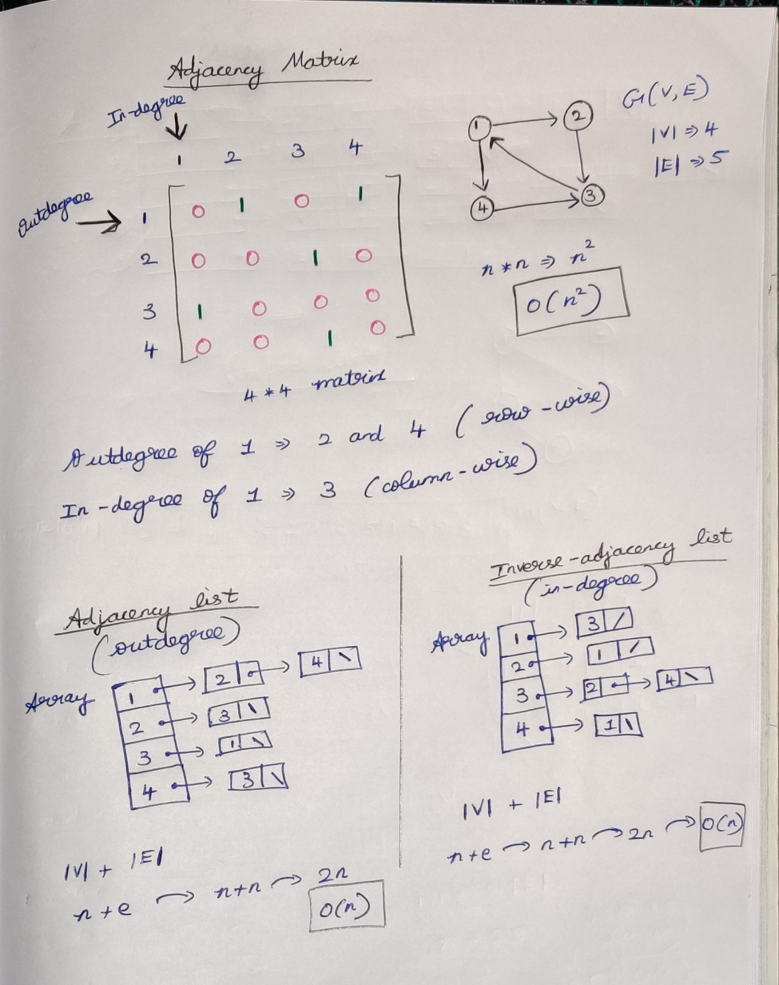

# **Breadth First Search (BFS)**

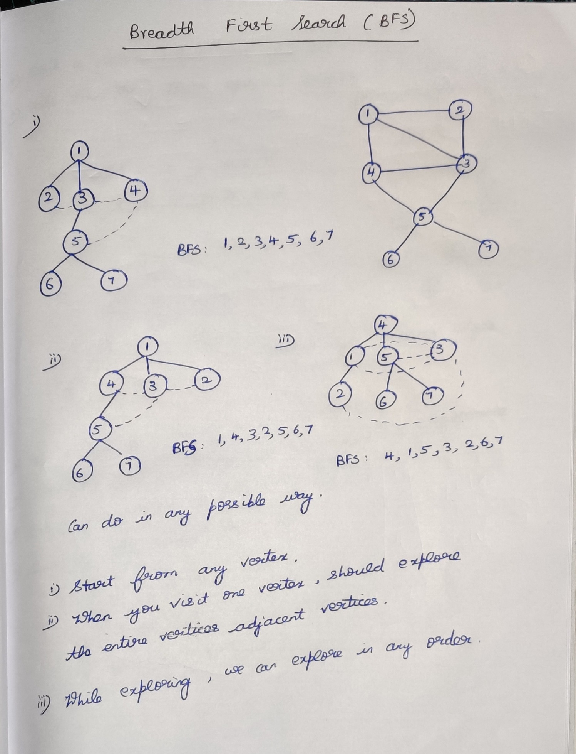

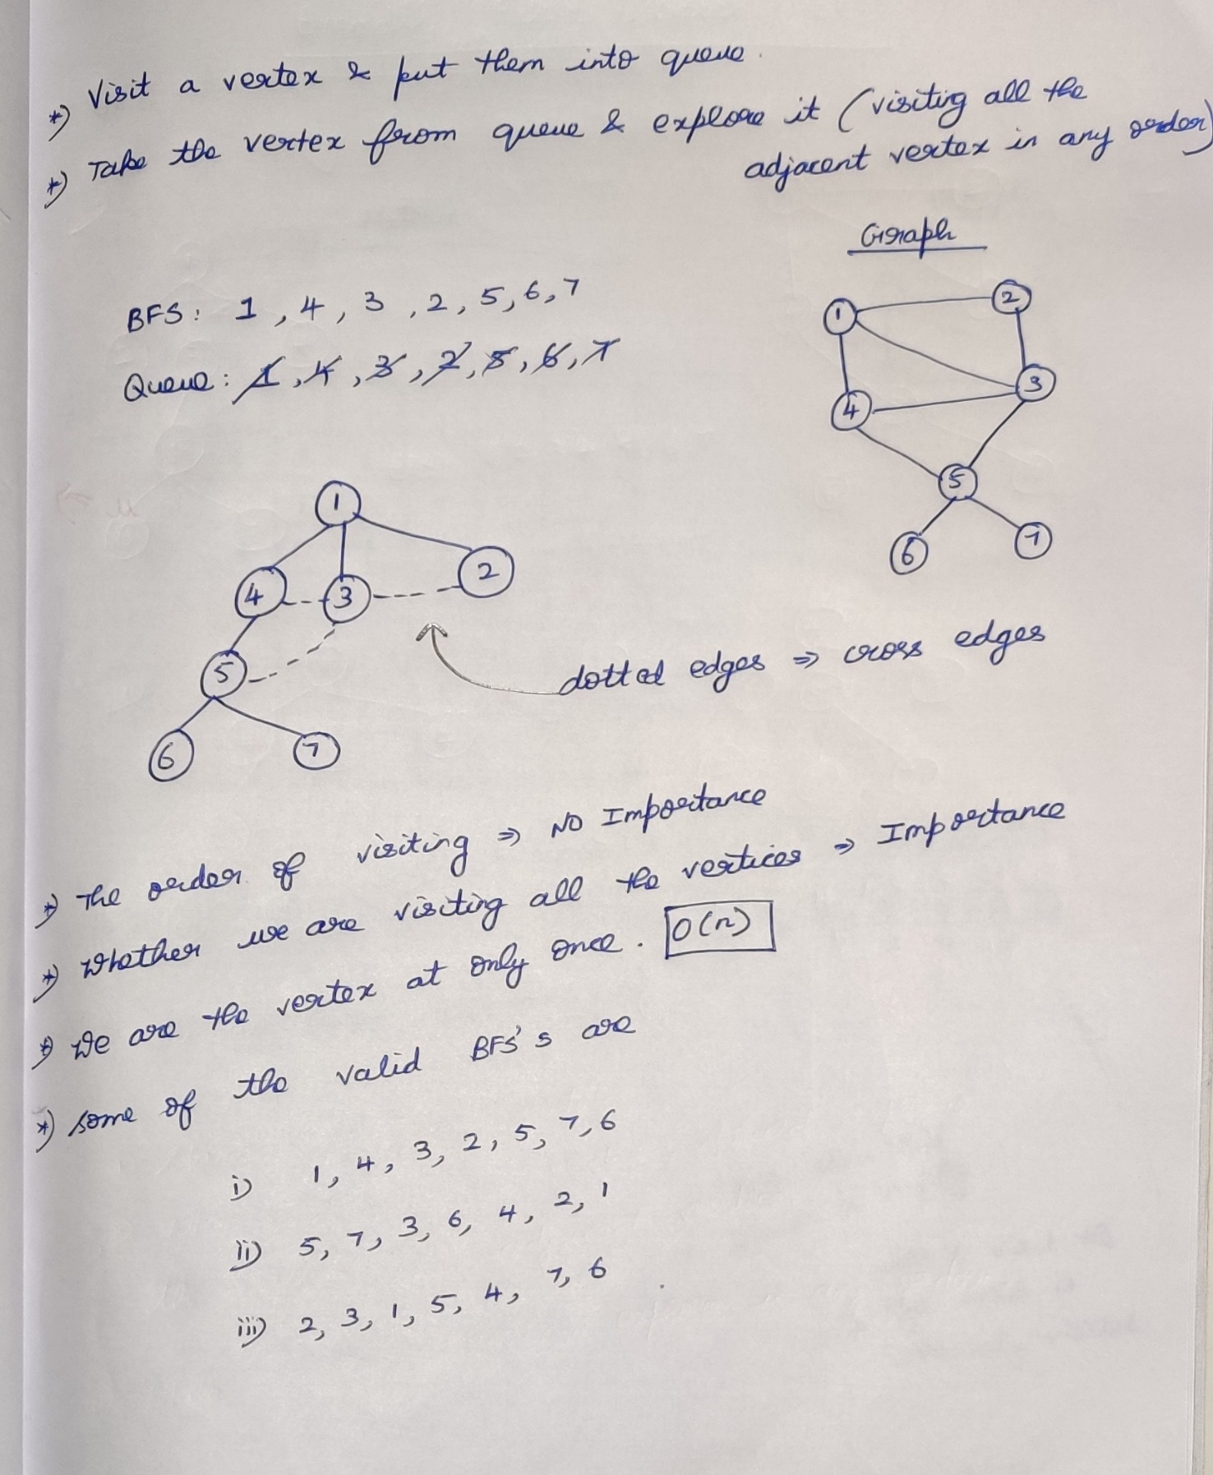

## **Algorithm for Breadth First Search (BFS)**

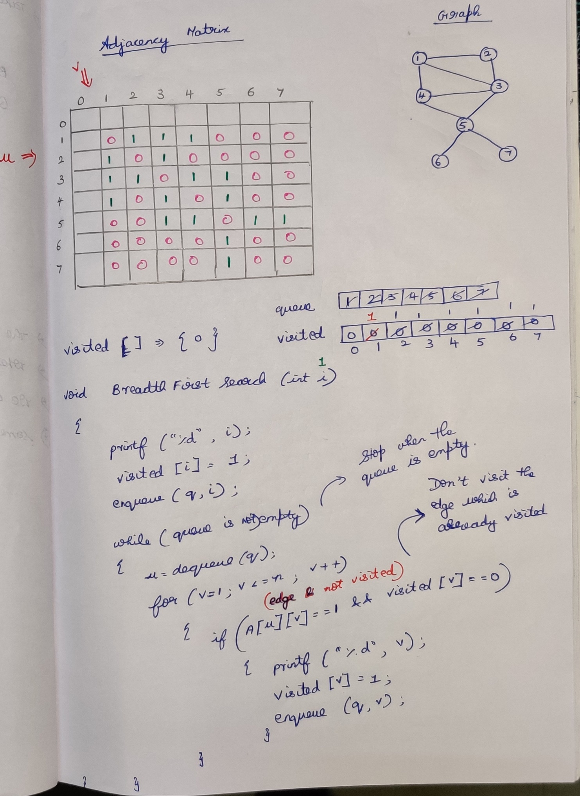

# **Depth First Search (DFS)**

## **Algorithm for Depth First Search (BFS)**